It’s Time for Some Fun at the Family Fun Center
Let’s Celebrate Our Years at Inglewood

Parent and Student Information:

Please read the following information and guidelines carefully…

- Our goal is to have a safe and fun celebration
- Participation in the celebration is a privilege; administrators can exclude students for poor citizenship during the school year
- The gym doors will open at 4:45 but please be here by 5:00 to load the buses
- School rules apply at the Family Fun Center
- Dress is totally casual and you should wear clothes that are school appropriate and allow you to run around and have fun
- School dress code applies and is in effect, including no skirts or shorts shorter than students’ fingertips and no spaghetti straps
- No backpacks or large purses are needed-there are fee-based lockers but there are a limited amount of them
- Please keep track of sweaters, coats, cameras, etc. during the evening and watch your belongings-you are responsible for them
- Bus assignments will be posted before the event
- All students must ride their assigned bus to and from the Family Fun Center
- Parents, please pick up your student from Inglewood following the event. Buses should arrive around 9:45
- Food and drinks will be supplied for students during the event as part of the package-there will be pizza, soda, and a salad
- Ticket payment ($50) and permission slips should be turned in to the ASB Office- Please make checks out to Inglewood Junior High
- Deadline is June 1st, 2012
- This is a celebration for all of our 8th graders and we would like them all to be there
- If you need assistance with ticket payment, please contact Karen Rasler at 425-936-2360 or krasler@lwsd.org
- The Family Fun Center is exclusively reserved for our school so let’s have a great time and enjoy the park one last time together as Knights

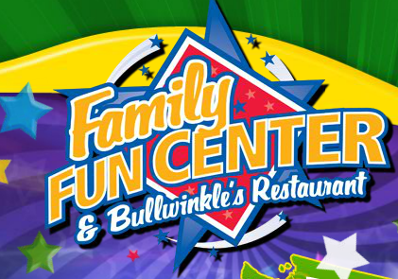

It’s the first ever Inglewood night at the Family Fun Center
Come be a part of the tradition and celebrate the first ever 8th grade class promotion
We want you all to attend this fun event
We will have the park all to ourselves

WE WANT YOU FOR A FUN NIGHT!
Friday, June 15th, 2012

