Inglewood “Knight” Showcase

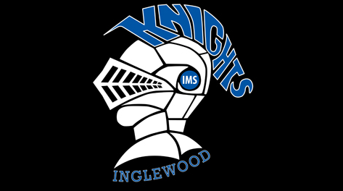
June 2, 2015

Time Block | Event/Activity - Location
5:30 – 6:00 | 4K AHA Fun Run or Walk (Road Course / Football field finish)
6:00 – 6:15 | Band Performance (Commons) |  |  |  | Pickle Ball  (Gym) | Art (Courtyard) | Carnival Games (Football Field)  Scavenger Hunt (Courtyard)  “Selfie” Station  (Commons)  Food Trucks  (Courtyard)  -Pizza – Zeek’s  -Ice Cream – Ben and Jerry’s  -Mexican –  Los Chilangos  -Hot-Dogs –  Dantes
6:15 – 6:30

6:30 – 6:45 |  | Rocket Launch (Football Field) | School Clubs  (Patio/Courtyard)  - Games club  - Harry Potter Club  - Lego / Robotics club  - Kindness club  - Leadership program  - Science club  - Yearbook club  - Dr. Who club  - Chess club  - Star Wars club  - Math club  - Green Team  *Clubs will be setting up for 15 and taking down for 15 during this time | Field-Goal kicking Competition (Football Field)
6:45 – 7:00 | Media Production Videos (Commons)
7:00 – 7:15 |  |  |  |  | Basket-ball  (Gym) | Foods/Gen Tech (Courtyard)
7:15 – 7:30 | Orchestra Performance (Commons)
7:30 – 7:45

7:45 – 8:00

Event Descriptions
Performances – Band and Orchestra students will be playing some of this year’s pieces they have been working on. Media Production students will be screening what they created this year in class.
Rocket Launch – 7th grade science students have created rockets and will be launching them on the north side of the football field. Anyone is welcome to launch previously launched rockets.
School Clubs – The school clubs listed above will be displaying content from their clubs. They welcome participants, questions and casual conversations.
Gym Activities – There will be pickle-ball and basketball in the gym throughout the evening all ability levels are welcome to participate.
Field Goal Kicking Competition – come a kick a field goal, challenge someone else to kick with you and see who can make the most!
Art – There will be a clay table and drawing table to see what students have been working on this year as well as supplies to create your own masterpiece.
Foods/Gen Tech – The CTE electives will be displaying content from their classes.
Carnival Games – There will be a variety of games offered with small prizes on the football field (these will run the entire evening)
Scavenger Hunt – Pick up your scavenger hunt paper, find all the knights around the school and you could win a prize
Selfie Station – Come take your picture with your friends, family or have a solo shot at our “selfie booth”
Food Trucks – Stop by and get something to eat for dinner, a variety of foods will be offered. Cash is preferred.

Inglewood “Knight” Showcase

June 2, 2015

NE 8th Street
ST.
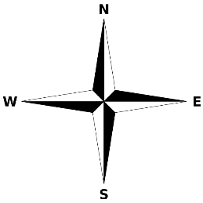
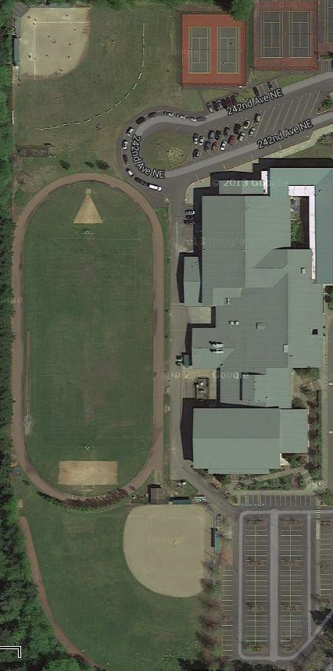
Field Goal Kicking
Rocket Launch
Parking Lot
Softball Field
Baseball Field
Commons
Courtyard
Gym
Football Field

Thank you to the IMS Knight Showcase committee for their vision, the PTSA for their support, and IMS staff members actively showcasing their work.

