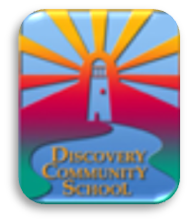

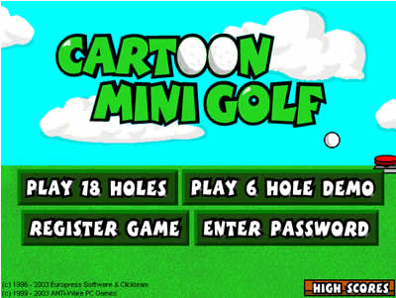

Create your own mini golf station for the DCS mini golf course! Make your own station with your family and bring the finished product to the event (instead of making it at the event) so that there will be ample time to set up stations and play at each station. Mini golf holes (cups) will be sent home at the end of this week.

Volunteer Opportunities:

Email [***Jessicasoltani@gmail.com***](mailto:Jessicasoltani@gmail.com%3cmailto:Jessicasoltani@gmail.com) if you are interested in:

-set up (6:30-7)

-clean up (8:30-9)

-making or donating treats/snacks for the concessions stand to help raise money for the Olders’ camp

-volunteering at the concessions stand (email if you would like to sign up your Olders’ student for a 30 minute spot or if you would like to assist the Olders in manning the concessions stand)

*Volunteer positions will be filled on a first-come, first-serve basis