Dads and Donuts
June 5th
7:00 to 8:40 am
Dads- bring your child(ren) and join us for breakfast
7:00 AM to 8:40 AM
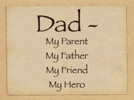$3.00 per breakfast
Keller Gym
Menu :
Donuts
Fruit/Coffee/Tea/Juice

