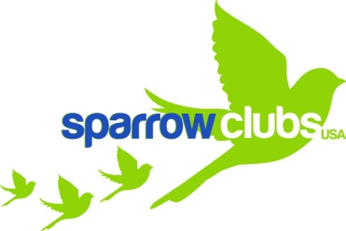

Spring Clean at Franklin!

A community service opportunity
School clean up
Wednesday 20th March (at lunch recess)

K-2 11.50 am to 12.20 pm
3, 2/3 and 3/4 Quest 12.20 pm to 12.50 pm
4/5 and 4/5 Quest 12.50 pm to 1.20 pm

- Trash bags and gloves provided.
- Just bring your smile!
- Meet outside, by A-pod stairs.

