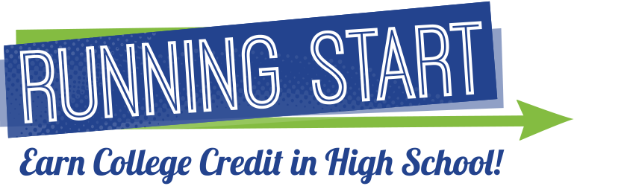
_________________________________________________
Are you interested in the Running Start Program for the 2017-2018 school year?
Come join us for our Running Start Information Session to learn how to enroll!
_______________________________________________
WHO: Current 10th and 11th graders students and their families
WHAT: Running Start Information Session
WHEN: Wednesday, February 22nd @ 12:30 pm
WHERE: RHS Performing Arts Center (PAC)
WHY: To learn more information and how to enroll in the Running Start programs at Bellevue College, Lake Washington Institute of Technology, and Cascadia College!

